**7DAILY ONLINE ACTIVITIES SUMMARY**

|  |  |  |  |  |  |  |  |  |
| --- | --- | --- | --- | --- | --- | --- | --- | --- |
| **Date:** | **3-6-2020** | | | | | **Name:** | **Prajna** | |
| **Sem & Sec** | **8th sem ‘B’** | | | | | **USN:** | **4AL16CS067** | |
| **Online Test Summary** | | | | | | | | |
| **Subject** | | **-** | | | | | | |
| **Max. Marks** | | **-** | | **Score** | | | **-** | |
| **Certification Course Summary** | | | | | | | | |
| **Course** | **Steps in RPA** | | | | | | | |
| **Certificate Provider** | | | **Great Learning** | | **Duration** | | | **3hrs** |
| **Coding Challenges** | | | | | | | | |
| **Problem Statement:**1**.** Write a python program to print permutations of string. | | | | | | | | |
| **Status: Completed** | | | | | | | | |
| **Uploaded the report in GitHub**  **GitHub link:** | | | | | **Yes**  **https://github.com/alvas-education-foundation/prajna_k** | | | |
| **If yes Repository name** | | | | | **prajna_k** | | | |
| **Uploaded the report in slack** | | | | | **yes** | | | |

Online Test Details: (Attach the snapshot and briefly write the report for the same)

Certification Course Details: (Attach the snapshot and briefly write the report for the same)

Coding Challenges Details: (Attach the snapshot and briefly write the report for the same)

2) certification course

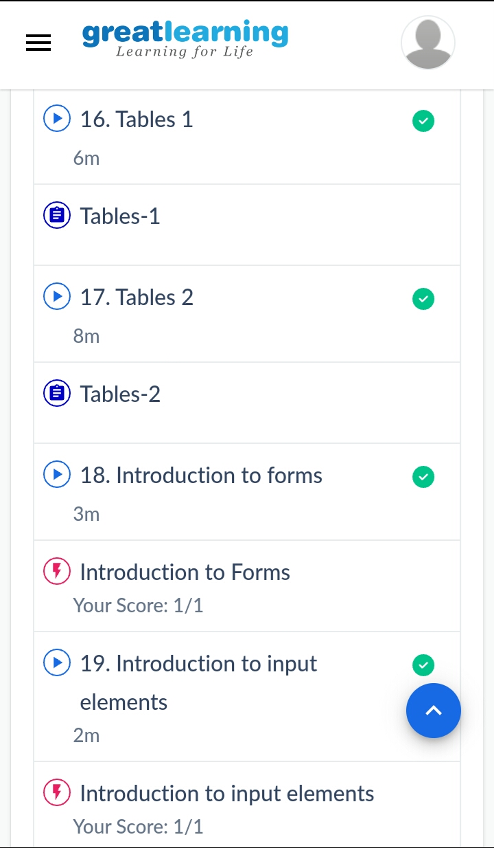

3) coding challenges

Program 1

def permute_string(str):

if len(str) == 0:

return ['']

prev_list = permute_string(str[1:len(str)])

next_list = []

for i in range(0,len(prev_list)):

for j in range(0,len(str)):

new_str = prev_list[i][0:j]+str[0]+prev_list[i][j:len(str)-1]

if new_str not in next_list:

next_list.append(new_str)

return next_list

print(permute_string('ABCD'));

|  |
| --- |
|  |
|  |  |
|  |  |
|  |  |
|  |  |
|  |  |